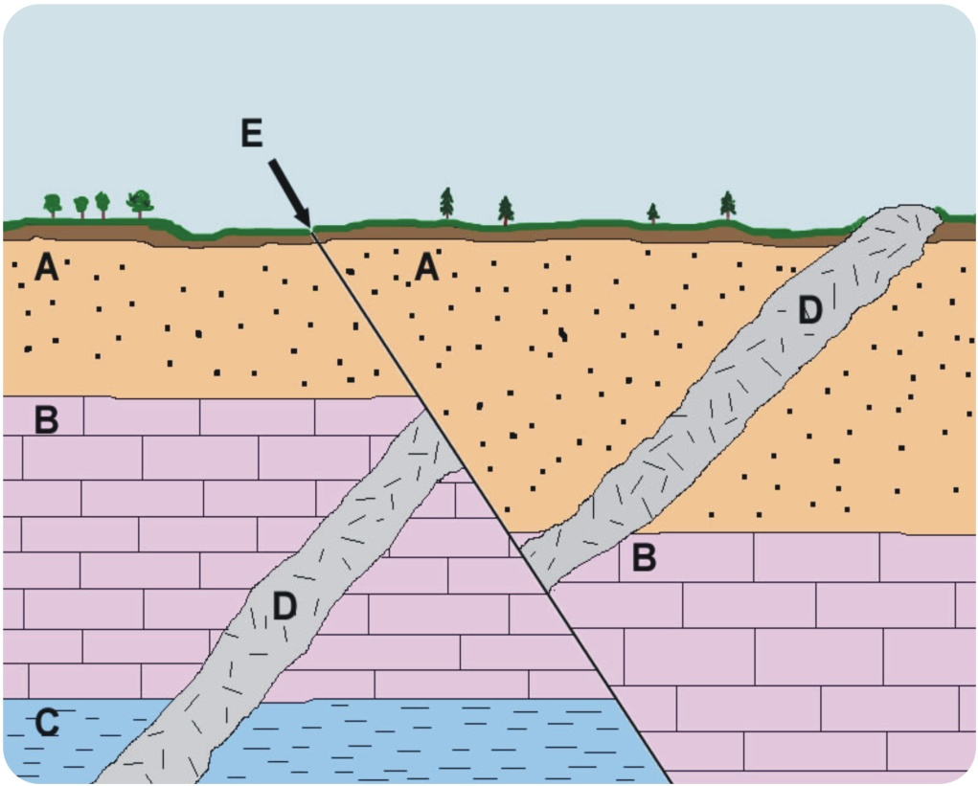
Change Over Time Unit Test-Study Guide
1. What are the three types of faults/plate boundaries?
-What happens between the plates at each boundary?
2. What does the Mid-Atlantic Ridge show us?
3. How old is the Earth?
4. What are the different types of fossils? How are they formed? Be able to compare and contrast them and give examples.
5. Which type of rock (Igneous, Metamorphic, Sedimentary) is most abundant on Earth?
6. Who is Alfred Wegner? How did he come up with the Theory of Plate Tectonics?
7. What is the Theory of Plate Tectonics?
8. What is absolute dating?
9. What is radioactive dating? How is it used?
10. What is an isotope?
11. Be familiar with the Law of Superposition, and how it can be demonstrated in diagrams:
-What is it?
-What does it tell us?
12. What is an igneous intrusion? What does it tell us about its age in relationship to the layers around it?
13. What is an unconformity?
14. Put the layers, in the diagram to the right, in order from oldest to youngest.
15. What are ice cores? How are they used? What evidence do they provide
about climate change?
16. What causes the end of an era?
17. In what era did life first begin on Earth?
18. In what era do we currently live?
19. Define evolution, and natural selection. How are they different?
“Winning, is the science of being totally prepared.” –George Allen, Sr.

Test Date: Thursday, February 25
*This study guide is to help you prepare for the Unit Test. It is a guide to point you in the right direction of what to study. It is not an exhaustive list of topics which might be covered on the test. Any information from the Change Over Time Unit is fair game.
20. What is population variation? How does having “favorable” traits, affect survival?
**In relationship to the amount of time Earth has existed, humans have existed for a very small, teeny, tiny portion.**

