History of the Atom
Atoms are very tiny. They could not be seen before scanning tunneling microscopes were invented in 1981. However, the idea of atoms goes back to ancient Greece. That’s where this brief history of the atom begins.
Democritus: Introduction and Rejection of the Atom
The history of the atom begins around 450 B.C. with a Greek philosopher named Democritus. Democritus wondered what would happen if you cut a piece of matter, such as an apple, into smaller and smaller pieces. He thought that a point would be reached where matter could not be cut into still smaller pieces. He called these "uncuttable" pieces atomos. This is where the modern term atom comes from.
Democritus was an important philosopher. However, he was less influential than the Greek philosopher Aristotle, who lived about 100 years after Democritus. Aristotle rejected Democritus’s idea of atoms. In fact, Aristotle thought the idea of atoms was ridiculous. Unfortunately, Aristotle’s ideas were accepted for more than 2000 years. During that time, Democritus’s ideas were more or less forgotten.
John Dalton: Bringing Back the Atom
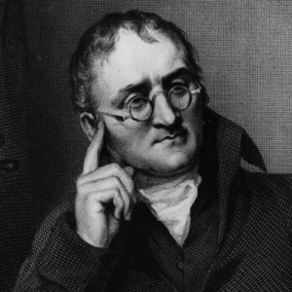
Around 1800, a British chemist named John Dalton revived Democritus’s early ideas about the atom. He made a living by teaching and just did research in his spare time. Nonetheless, from his research results, he developed one of the most important theories in science.
Dalton did many experiments that provided evidence for atoms. For example, he studied the pressure of gases. He concluded that gases must consist of tiny particles in constant motion. Dalton also researched the properties of compounds. He showed that a compound always consists of the same elements in the same ratio. On the other hand, different compounds always consist of different elements or ratios. This can happen, Dalton reasoned, only if elements are made of tiny particles that can combine in an endless variety of ways. From his research, Dalton developed a theory of the atom.
John Dalton's Atomic Theory
The atomic theory Dalton developed consists of three ideas:
- All substances are made of atoms. Atoms are the smallest particles of matter. They cannot be divided into smaller particles. They also cannot be created or destroyed.
- All atoms of the same element are alike and have the same mass. Atoms of different elements are different and have different masses.
- Atoms join together to form compounds. A given compound always consists of the same kinds of atoms in the same ratio.
Dalton’s theory was soon widely accepted. Most of it is still accepted today. The only part that is no longer accepted is his idea that atoms are the smallest particles. Scientists now know that atoms consist of even smaller particles.
John Dalton's Atomic Models
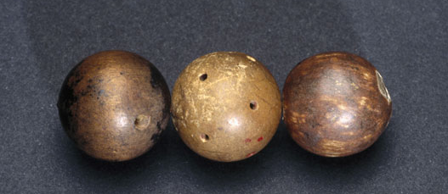
Dalton incorrectly thought that atoms are tiny solid particles of matter. He used solid wooden balls to model them. The model below shows how Dalton’s model atoms looked. He made holes in the balls so they could be joined together with hooks. In this way, the balls could be used to model compounds. When later scientists discovered subatomic particles (particles smaller than the atom itself), they realized that Dalton’s models were too simple. They didn’t show that atoms consist of even smaller particles. Models including these smaller particles were later developed.
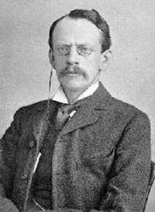
J.J. Thompson: Adding Electrons
The next major advance in the history of the atom was the discovery of electrons. Many scientists of Thompson’s time thought that electric current consists of rays, like rays of light, and that it is positive. Thompson’s experiments showed that an electric current consists of flowing, negatively charged particles. Thompson’s experiments also showed that the negative particles are all alike and smaller than atoms. Thompson concluded that the negative particles couldn’t be fundamental units of matter because they are all alike. Instead, they must be parts of atoms. The negative particles were later named electrons. These were the first subatomic particles to be identified. They were discovered in 1897 by the British physicist named J. J. Thompson.

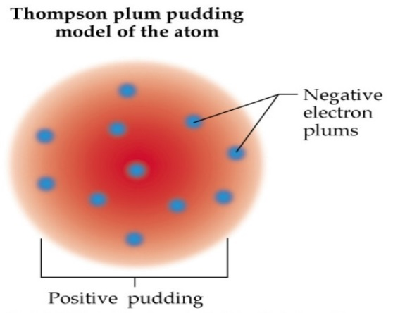
Thompson’s Plum Pudding Atomic Model
Thompson knew that atoms are neutral in electric charge. So how could atoms contain negative particles? Thompson thought that the rest of the atom must be positive to cancel out the negative charge. He said that an atom is like a plum pudding, which has plums scattered through it. That’s why Thompson’s model of the atom is called the plum pudding model. You can see it in Figure (to the right). It shows the atom as a sphere of positive charge (the pudding) with negative electrons (the plums) scattered through it.

Ernest Rutherford: Finding the Nucleus
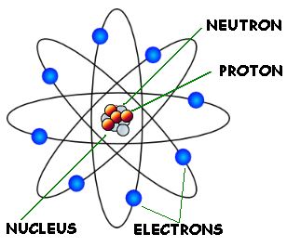
A physicist from New Zealand named Ernest Rutherford made the next major discovery about atoms. He discovered the nucleus. In 1899, Rutherford discovered that some elements give off positively charged particles. He named them alpha particles. In 1911, he used alpha particles to study atoms. He aimed a beam of alpha particles at a very thin sheet of gold foil. Outside the foil, he placed a screen of material that glowed when alpha particles struck it.
Based on his results, Rutherford concluded that all the positive charge of an atom is concentrated in a small central area. He called this area the nucleus. Rutherford later discovered that the nucleus contains positively charged particles. He named the positive particles protons. Rutherford also predicted the existence of neutrons in the nucleus. However, he failed to find them. One of his students, a physicist named James Chadwick, went on to discover neutrons in 1932.

Rutherford's Atomic Model
Rutherford’s discoveries meant that Thompson’s plum pudding model was incorrect. Positive charge is not spread out everywhere in an atom. It is all concentrated in the tiny nucleus. The rest of the atom is empty space, except for the electrons moving randomly through it. In Rutherford’s model, developed in 1911, electrons move around the nucleus in random orbits. He compared them to planets orbiting a star. That’s why Rutherford’s model is called the planetary model.

