Population and Genetic Variation
Read, Annotate, and then use this information to help you with the “Simpsons Population Variation”.
The cheetah, Acinonyx jubatus, is the sole member of its genus. Twenty thousand years ago, cheetahs roamed throughout the savannahs and plains of four continents: Africa, Asia, Europe, and North America. About 10,000 years ago - because of climate changes - all but one species of the cheetah, jubatus, became extinct. With the drastic reduction in their numbers, close relatives were forced to breed, and the cheetah became genetically inbred, meaning all cheetahs are closely related.
Inbreeding occurs when members of the same family or close relatives breed only among themselves. For example, when you look around, you see different hair colors, eye colors, and heights. If you took blood from everybody in the room, and looked at the proteins in the blood, you would see proteins also vary between each person, just like hair color. When you look at the proteins in the blood of cheetahs, they are very similar; it looks as if they are identical twins of one another, meaning they are closely related.
The study of biological inheritance is called "genetic research." Genes, which are composed of DNA, store the information that an individual inherits from his or her parents. Genes in one animal vary from the same genes in another animal of the same species. By looking at the amount of variation existing in genes, scientists, called "geneticists" can begin to understand the relationships of animals within population, and how infectious diseases may affect that population. Also, by comparing the amount of variation between different species, geneticists can help us understand the process of evolution.
When geneticists looked at the amount of variation within the genes of the cheetah, they found that cheetahs exhibit much lower levels of variation than other mammals. In most species, related individuals share about 80 percent of the same genes. With cheetahs, this figure rises to approximately 99 percent. The genetic inbreeding in cheetahs has led to low survivorship (a large number of animals dying), poor sperm quality, and greater susceptibility to disease. Inbred animals suffer from a lack of genetic diversity. This means cheetahs lack the ability to adjust to sudden changes in population of leopards, not every animal dies; some do, because leopards are genetically diverse. But if every animal is genetically the same, like the cheetah, and one gets infected, all of them may become infected and die off. Because of their lack of genetic diversity, a deadly virus could wipe out all of the worlds' wild cheetahs instead of just the susceptible animals. It depends on a species' genetic differences.
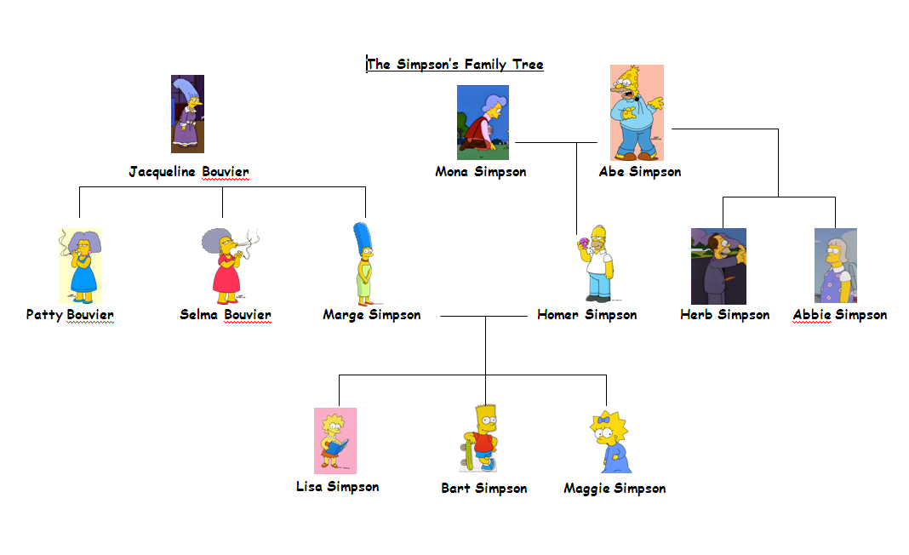
Evolution eliminates traits in organisms that are least suited for survival. Some of the decline in the cheetah's genetic diversity is accounted for by its specialization through natural selection. The decrease in genetic diversity resulting from natural selection has benefited the species' survival as it has made the cheetah better adapted to its environment. However, the effects of this occurrence are small when compared to the effects of the inbreeding that occurred 10,000 years ago from a population bottleneck. To increase genetic diversity in captivity, zoos take great care to make sure that only unrelated animals mate. Using modern technology, genetic information can be collected from wild Namibian Cheetahs for use in captive breeding programs. Because Namibia has the largest population of cheetahs, the genes represented in this population are important to captive cheetah survival worldwide.
Use this family tree to help you answer the questions on the back!
The Simpson Family Tree

