Change Over Time Unit: Challenge Questions
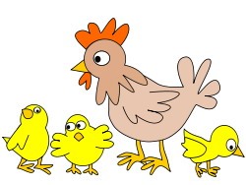
1. What trait determines whether two animals belong to the same species? Choose the best answer.
A. The environment they live in
B. Their physical appearance
C. Their ability to breed with one another
D. Their evolutionary relationship to humans
2. Which of the following is an example of an environmental pressure?
A. The air pressure in the atmosphere
B. A lake that's gradually running out of water
C. A fight between two members of the same species
D. Breeding between two members of the same species
3. What can you infer from the fact that all life on Earth is related, if you go back far enough?
A. Many different species existed at the beginning of time
B. Very few species have gone extinct over time
C. Animals mutate and evolve at an extremely rapid rate
D. All life on Earth evolved from just a few simple life forms

4. How are camels especially suited to their environment? Choose the best answer.
A. Their humps make them good pack animals for humans
B. Their long eyelashes make them look attractive
C. They're able to go without water for long periods of time
D. They get along well with other members of their species

5. In the phrase "survival of the fittest," to what does the term "fittest" refer?
A. The best-adapted organisms
B. The biggest organisms
C. The smartest organisms
D. The fastest organisms

6. Which of the following is the most likely example of a favorable mutation?
A. A mutation that makes a rabbit able to run faster
B. A mutation that changes the color of a rabbit's fur to bright orange
C. A mutation that changes the color of a rabbit's eyes
D. A mutation that gives a rabbit a third ear

7. "Mutations are more likely to be passed along if they're advantageous to an organism." What does this sentence mean?
A. A genetic change that helps an organism survive is likely to be passed down from parent to child
B. Mutant parents are very likely to give birth to mutant children
C. Mutations inherited from an organism's parents rarely help that organism survive
D. Mutations are passed along from parent to child whether they help an organism survive or not
8. In what way is life on Earth similar to a large tree? Choose the best answer.
A. It is rooted in the ground
B. All of the different branches are connected
C. All of life needs water to survive
D. It cannot move under its own power
9. What is a common ancestor?
A. An animal that has a lot of offspring
B. An animal that is related to many other species
C. An animal from which two or more different species evolved
D. An animal that's good at escaping from predators
10. Species go extinct when:
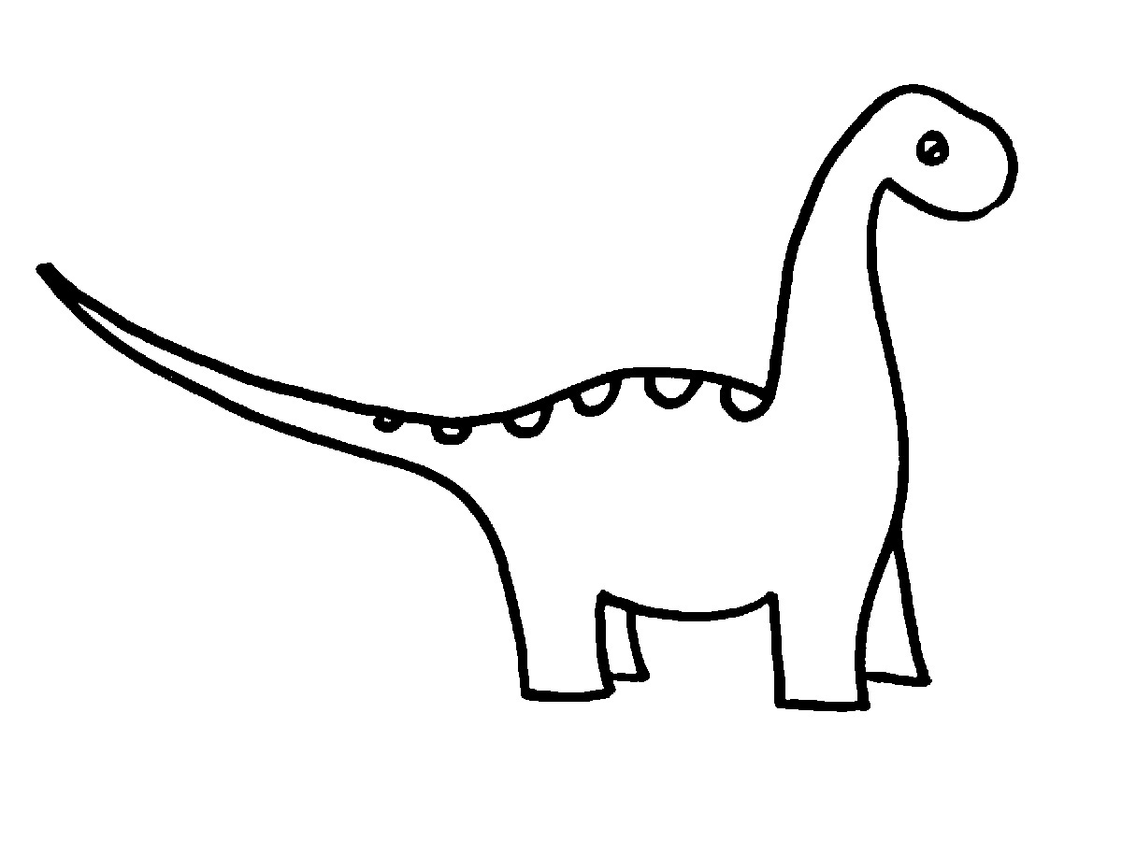
A. They've survived for longer than ten million years
B. They can't adapt to environmental changes
C. Their genetic code changes
D. They lose the ability to evolve

11. What is evolution?
A. When animals move to warmer climates in the winter
B. How organisms change across many generations
C. The migration of different species through the seasons |
D. Ancient rock layers and the fossils they contain
12. According to the theory of evolution, which of the following statements is true?
A. Humans evolved from chimpanzees
B. Chimpanzees evolved from humans
C. There is no evolutionary relationship between humans and chimpanzees
D. Humans and chimps evolved from a common ancestor

13. If the fossil record of human evolution is incomplete, why do scientists still believe humans evolved from ape-like ancestors?
A. Because existing evidence in the fossil record strongly suggests it
B. Because scientists make a lot of money by promoting the theory of evolution
C. Because the theory of evolution is more than 100 years old, which means it must be correct
D. Because humans and apes look similar to one another

14. How is a scientific theory different from a guess?
A. Theories are created by scientists; guesses are made by regular people
B. Theories are backed up by evidence; guesses are not
C. Theories are usually longer than guesses
D. "Theory" is simply a fancier word for "guess"
15. What trait is most likely to be passed on from one generation to the next?
A. A trait that helps a creature avoid predators
B. A trait that prevents an animal from seeing well
C. A trait that prevents a creature from reproducing
D. A trait that has no effect on a creature's life

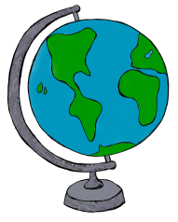
16. If you wanted to excavate fossils of the earliest human ancestors, to what country might you travel?
A. Australia
B. China
C. Kenya
D. Iceland
17. Which of the following is a true statement about the members of a species?
A. They must live in the same geographic area
B. They must be able to breed with one another
C. They must be able to move under their own power
D. They must not be extinct at the present time
18. According to most scientists, what is the ultimate cause of most mass extinctions?
A. Overhunting
B. The evolution of new species to replace old ones
C. Major changes in the environment
D. Asteroid impacts

19. What can you conclude from the fact that more than a billion species have gone extinct during Earth's history?
A. Extinction is a natural part of life on Earth
B. Extinction happens only rarely
C. The rate of extinction has increased since humans evolved D. The earth's environment is not good at supporting life

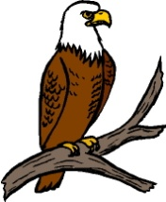
20. The bald eagle almost went extinct when humans began using a pesticide called DDT. What can you conclude from the fact that bald eagle numbers have since rebounded?
A. The bald eagle is one of the hardiest birds on Earth
B. The eagles learned to stay away from areas where the pesticide was sprayed
C. The eagles quickly evolved to tolerate the pesticide
D. The pesticide was banned

21. How has the expanding human population led to an increasing rate of extinction? Choose the best answer.
A. Humans kill and eat too many other species
B. Humans re-shape their environment, putting pressure on other species
C. Humans have been forced to destroy dangerous, violent species
D. Humans consume too much oxygen, preventing other species from breathing.
22. How can the extinction of a plant species have such a drastic effect on a food chain? Choose the best answer.
A. Food chains are all composed of several types of plant and several types of animal, so if one plant dies out, the chain breaks down.
B. Plants are the main source of food for carnivores like bears, so if plants go extinct, bears will starve.
C. Food chains rely on certain types of plants to function properly, so if a plant dies out, all the other species in the food chain will die out, too.
D. If the extinct species was the main food source for another animal, that animal will have to find a new way to survive.

23. Which of the following words best describes the process of evolution?
A. Responsive
B. Directed
C. Violent
D. Eternal

