EPA Virtual Tour- Water Treatment Plant
Instructions:
1. Go to http://www.epa.gov/ogwdw/watertreatmentplant/flash/index.html. When given the option, select English.
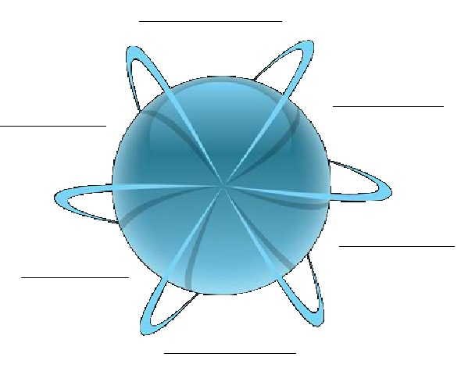
2. Watch as Thirstin introduces you to the way the virtual tour will work. Pay attention, because this where you will receive most of the directions.
3. As you watch, fill in the stages of water treatment in the chart:
4. At the end of the introduction, it will ask you to choose
between “Quality and Safety”, “Cost”, and “Environment” .
There is no wrong answer so choose one, and watch the
short video. In the space provided below, list at least one fact explained in
the video you selected.

5. When the video is finished you will begin to “Tour the
Plant”. Using the control panel shown below, navigate through each step
in the water treatment process and complete the activities.
Coagulation and
Flocculation
Pretreatment and Screening
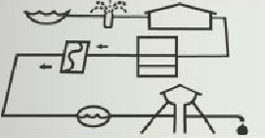
Analysis:
Source Water and Intake:
1. In what ways might water be treated differently base on the quality of source water?
2. Give three examples of threats to water sources that are found in most riverbasins.
Distribution and Storage
Disinfection
Filtration
Source Water and Intake
Sedimentation

