Analysis Continued:
Pretreatment and Screening:
1. How are screens used in pretreatment?
2. Define aeration. How does this help the treatment process?
3. Why might chlorine be added to the water during this stage?
Coagulation and Flocculation:
1. What does the coagulation and flocculation step of the water treatment process remove?
2. What does a coagulating agent do?

3. What is a “floc”?

Sedimentation:
1. The sedimentation process, along with coagulation and flocculation, remove many of the particles that make
water ____________________.
2. On average, how long does water stay in this stage?
Filtration:
1. What is the main job of the filtration step? (Do not simply say “to filter”.)
2. Describe several different types of filters.

Disinfection:
1. Name the most common disinfectants used in water treatment?
2. What are some of the concerns with mixing disinfectants with naturally occurring organic matter?
Distribution and Storage:
1. What types of equipment are used in a distribution system?
2. Why are valves necessary in a distribution system?

3. Why is calcium hydroxide used in some distribution systems?
4. How do they decide where to put a water tower? Why is this criteria important?
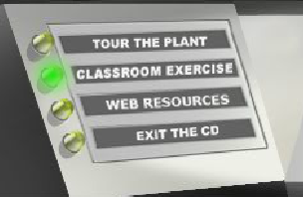
When you are finished with the tour, click on the “Classroom Exercise” button on the
left side of the screen. It looks like this:
1. Complete “Thirstin’s Matching Fun Facts” and answer the questions below.
How much water do we use to take a shower? _____________________________
How much water do we use to do the dishes? ______________________________
How much water do we use to flush the toilet? _____________________________
List one additional water fact that you found most interesting.

2. Now try Thirstin’s Word Scramble. How many sentences did you complete correctly? _______/8.

3. Click on the “Water Cycle” activity. As you go through the activity, include some of the facts you learned to write a paragraph explaining the water cycle to a third grader.

4. If time allows, look through the water tower gallery. Which is your favorite? Why? What makes it unique?

