Q’s  Fossil Packet | Four Winged Dinosaur
How long ago did this dinosaur live?  Where were the fossils found?  When did this dino use the extra wings for?  What did other scientists think?  What do you think aerodynamic means?  Are there more than one dino with four wings? | For some animals, two wings just won’t do — as was the case for a four-winged dinosaur that lived 130 million years ago. Fossils of the creature were unearthed in China about 10 years ago. Since then, scientists have puzzled over how this dino used its two bonus wings. Now researchers report a likely answer.  In a new study, scientists Justin Hall and Michael Habib and their collaborators suggest the dino tucked its hind wings under its body most of the time. It brought the extra wings out only when it needed to make tricky turns in midair. To make a right turn, the dino would lift its left hind wing, for example.  Hall and Habib, who work at the University of Southern California in Los Angeles, presented the new idea about these dinos at a recent meeting of scientists who research prehistoric animals.  Other scientists had suggested that the dinosaur glided through the air either with all four wings out or with one pair positioned beneath the other, like the wings on a plane. Scientists are still arguing over whether the dinosaur could flap its wings and stay in the air like birds or just glide gently downward.  Keeping two wings hidden away when moving straight ahead would have made the dinosaur more aerodynamic, meaning it would have had a shape that let air flow past more freely. Extended all the time, the extra wings would have slowed the dino by creating resistance from the air. Air resistance, or drag, is the enemy of flight: A raindrop falls faster than a feather because air resistance doesn’t slow the drop down as much as the feather.  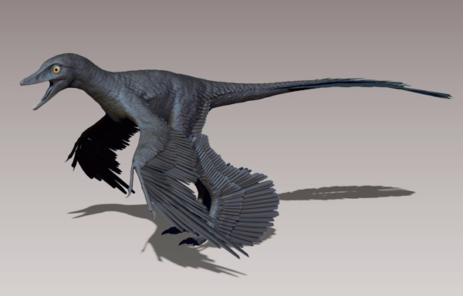  Hall and his collaborators studied the dinosaur Microraptor gui. It was the first found to have four wings. But it’s no longer the only one: Since M. gui’s discovery, other four-winged dinos have turned up. And their hind wings probably worked the same way, says dinosaur expert Luis Chiappe at the Natural History Museum of Los Angeles County

What were scientists able to learn about this dinosaur and others from
the fossils that were found? ___________________________________________________________________
__________________________________________________________________________________________
____________________________________________________________________________________________________________________________________________________________________________________1. Describe cast and mold fossils in your own words.
____________________________________________________________________________________________________________________________________________________________________________
- Describe trace fossils in your own words.
____________________________________________________________________________________________________________________________________________________________________________

- Describe preserved fossils in your own words.
____________________________________________________________________________________________________________________________________________________________________________

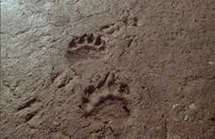
Ms. Ryan was hiking in New Mexico when she stumbled upon this fossil. Could you help her by explaining what kind of fossil it is and why you think so?
__________________________________________
__________________________________________
__________________________________________
__________________________________________
__________________________________________

- Another scientist found this fossil. Explain what kind of fossil it is, and how you know.
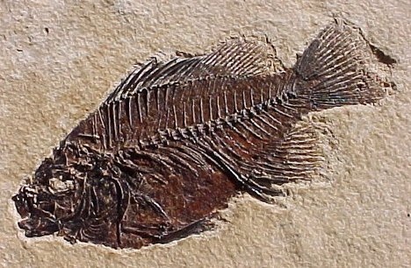
________________________________________________________________________________________
___________________________________________________________
___________________________________________________________
___________________________________________________________
___________________________________________________________
___________________________________________________________

Independent Practice

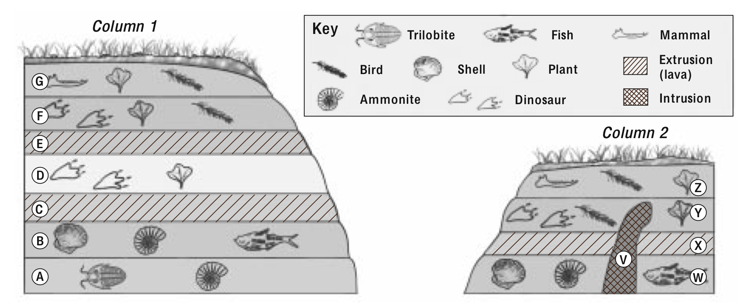

1. What “fossils clues” in layers A and B indicate the kind of environment that existed
when these rock layers were formed? How did the environment change in layer D?
__________________________________________________________________________________________
__________________________________________________________________________________________
2. Which layer is the oldest? How do you know?
__________________________________________________________________________________________
__________________________________________________________________________________________
3. Which of the layers formed most recently? How do you know?
__________________________________________________________________________________________
__________________________________________________________________________________________
4. Why are there no fossils in layers C and E?
__________________________________________________________________________________________
__________________________________________________________________________________________
5. What kind of fossils occurred in layer F?
__________________________________________________________________________________________
6. Order the layers in column 2 from oldest to youngest.
__________________________________________________________________________________________

Use the diagram to the right to answer question 6-11
Layer A
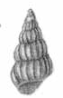

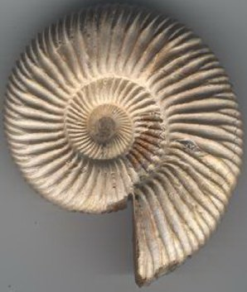
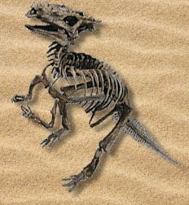Layer B

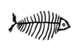Layer C

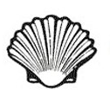
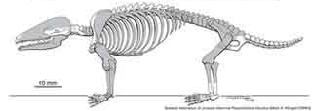Layer D

6. What types of fossils are in Layer A?

7. What type of environment existed when Layer A was formed?


8. What type of fossils are in layer B?

9. How did the environment change going from Layer B to Layer A?

10. What type of environment in the oldest layer?

11. What type of environment in the youngest layer?
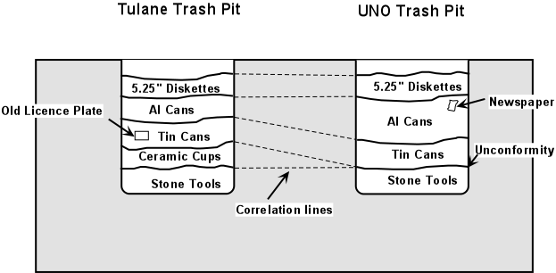

- This is a drawing of the University of Tulane’s old trash pit. All of these are items that have been thrown away – discs for computers, Aluminum cans, Tin cans, ceramic cups, and stone tools.
- Using relative age, which layer is the oldest? How do you know?
__________________________________________________
__________________________________________________
__________________________________________________
- Which layer found in the Tulane trash pit is the youngest? How do you know? ____________________________________________________________________________________
____________________________________________________________________________________

Mixed Review


