The Simpsons Family Tree
Using the Simpsons Family Tree found on the reverse side, answer the following questions in complete sentences. As you answer, think back to the Genetics Unit from last year, and how it relates to Population Variation.
1. What similarities can you see between Homer and Herb Simpson?

2. Marge and Jacqueline have similar hair. Which similarity is inherited and which is due to the way they live their lives? How do you know?

3. What relation is Herb to Abbie Simpson?

4. Who do you think Lisa, Maggie and Bart inherit their hair color from? What makes you think that?

5. What is the word scientists use to describe the differences between people, animals or plants? Why are differences between people, animals, or plants important?
Hint: It Starts With A “V”.

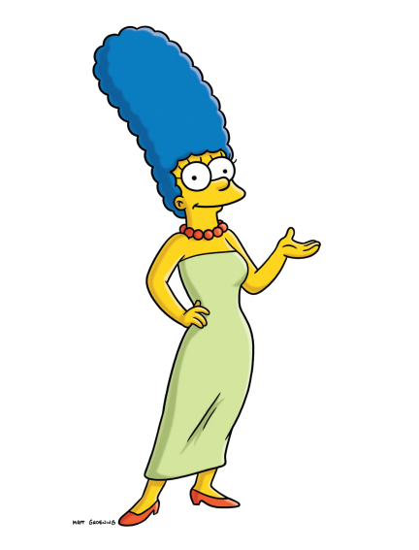
6. What is the name of the part of a cell which carries genetic information?

7. Patty and Selma are sisters and both have the same hair style. Is this an environmental or inherited
characteristic?

8. Bart has the same color skin as Homer. Is this an environmental or inherited characteristic?

9. When Principle Skinner sent Bart on his French exchange, Bart came back with a tan. What sort of characteristic is this?
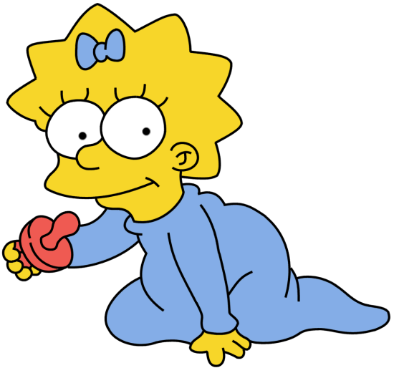
10. If the Simpsons were an entire species’ population, do you think there is enough variation for survival? Why or why not?
11. What information from the Cheetah article, is applicable to the Simpsons? How so? Explain.

